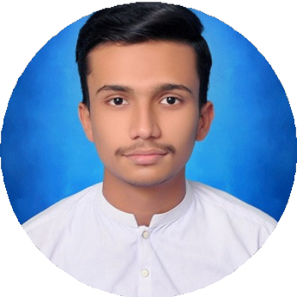
ABDUL REHMAN KHAN

COMPUTER SCIENCE STUDENT

Profile
Highly motivated Computer Science student with strong interest in web development, software engineering, and emerging technologies. Seeking opportunities to apply my skills and grow professionally in a dynamic environment.

Skills

- HTML
- CSS
- C++ Programming

- MS Office (Word, Excel, PowerPoint)
- Effective Communication
- Team Collaboration

Education History
BS Computer Science (In Progress) Mohammad Ali Jinnah University | 2024 - Present | CGPA: 3.22
DAE(CIT)
Government College | 2025 | Grade: A

HSC (Intermediate)
Government College | 2024 | Grade: A+

SSC (Matriculation)
Sun Rise Children Academy | 2022 Grade: A+

Contact Info

📞0319-2403285
✉rk4582284@gmail.com
📍 M- alir Colony ,Karachi
🔗linkedin.com/in/abdul-rehman-k han-06351a2b

Work Experience
HR Assistant - Internship
Transsion Tecno Electronics — [JULY, 2025 – SEPTEMBER , 2025]
Assisted in recruitment process including job postings, screening CVs, scheduling interviews, and coordinating with candidates.
Maintained employee records, attendance, and HR documentation in compliance with company policies
Coordinated training sessions, employee engagement activities, and onboarding programs.
Provided administrative support to HR department ensuring smooth day-to-day operations.

Certifications
WebsiteDevelopment | BanoQabil 2.0

Interests
Learning newtechnologies

Exploring innovative tools
Staying updated with tech trends

